Coaching Journal
Angelica Garcia
PL & Technology Innovation (ITEC 7460)
Kennesaw State University

Coaching Session 1: 10/22, 10/24/10/26 (30 minutes each)
Strategies
I met with Mrs. McCutchen three times for thirty minutes. These meetings were spread out throughout the course of one week and were combined to complete the first session. Over the first few sessions, we focused our time and effort laying out an outline of what Mrs. McCutchen was to be teaching during the span of our coaching sessions. According to Knight (2007), there are four items known as the Big Four, one of those is content knowledge. Although Mrs. McCutchen is an expert in her math content, she still wanted to see if the district pacing for her new unit would be fine with the rate her students are learning the content. Attached is a copy of the district’s math curriculum that Mrs. McCutchen uses to plan out her lessons.
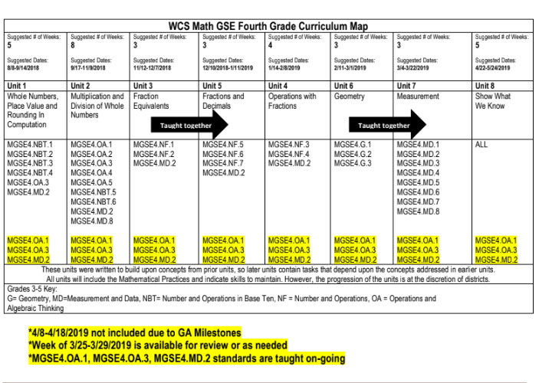
For this coaching session, I focused on using the strategy of mapping the content to fit it to her student needs. We used the district math-pacing guide as guidance to plan the second half of unit two.
Mrs. McCutchen and I met during our planning time. We discussed the results from the surveys she took and I explained to her the results. She admitted that integration of technology is definitely not her strength, but in order to decide how to implement right away, we both agreed on taking a step back and seeing the pacing of her unit. Besides mapping out her second half of the unit she is currently teaching, we also decided on ways that she can implement technology in ways that will be effective. She finds it difficult to implement technology in math because students have to be constantly be showing their work on paper. In addition, she herself does not feel comfortable using technology. However, she was excited to work with me to pace her unit and find effective technology tools that she can implement in her classroom. As Knight shares in chapter seven, “Once teachers recognize these structures, they can teach students to identify and recognize them in the content” (pg. 158.)
Now that Mrs. McCutchen was excited about working with me, and we tweaked the district curriculum guide she uses to plan her units, and we moved on to deciding what type of technology she wanted to implement in her lessons. I brought in my suggestions that I had for the current unit she is teaching and I took the time to introduce each of the tools. We also spent time exploring the tech tools that she liked. Some of the tools she liked were Khan Academy, Zearn and Prodigy.
Skill and Affective Change
This was my very first time interacting with another colleague as a coach. It was definitely a learning experience for Mrs. McCutchen and I. We quickly found that in order to implement technology, we first needed to assure the pacing of her content matched the needs of her students. This helped us see when and how we could implement the technology she found to be effective and engaging to her students. Most importantly she wanted to implemented a tool that would help her see student mastery of the content or not.
After collaborating with Mrs. McCutchen to explore the online tools I found for her, she found technology to be less intimidating. She appreciated me taking the time to research tools that she was able to explore herself. After completing the task of exploring the tools, Mrs. McCutchen became a little more open minded to the idea of implementing technology tools in her math classes.
Reflection on Challenges and Solution
I thought that this session went well, but there were several challenges I had to face. One of those main challenges was time. The meetings were not simply enough for us to share everything that I wanted to accomplish with Mrs. McCutchen. The time was ideal because our planning period flows into our lunchtime, however it was still a struggle saving time to meet, while still accomplishing our classroom responsibilities and squeezing lunch in between. Another challenge for me was my coaching plan. I found it difficult to explain to Mrs. McCutchen my goals and plan in a very short amount of time. I wanted to respect the time we set aside for the coaching meetings and I did not wanted to go over. To prepare myself next time, I will have a copy of the coaching plan so that I can explain the current steps and next steps to come in the future sessions. One solution I did found was the joy Mrs. McCutchen shared when we explored different online tools she could easily implement in her math classes. She shared how she was going to have one tool chosen for next time we meet so we can begin to plan her instruction around it.
Coaching Session 2: 10/29,10/31,11/2 (30 minutes each)
Strategies
Just like the first sessions, Mrs. McCutchen and I met three times for thirty minutes. These three sessions were combined as our second coaching session. During this session, we focused on the instruction Mrs. McCutchen was going to do where she was going to implement the online tool of her choice. Since the online tool was new to Mrs. McCutchen and her students, I decided to help her design an advance organizer and a post organizer. According to Knight, “advance organizers provide students with a context for learning, guide students to prior knowledge, prepare students for activities, and increase students’ enthusiasm for learning” (pg. 162.) As mentioned before, Mrs. McCutchen is an expert in her content, but she wanted to make sure she had an agenda for her students to follow on the day of introduction of the online tool. We quickly got to work and even recited the advance organizer so that it would not take no longer than three minutes. As stated in Knight’s book, “an effective advance organizer shouldn’t take more than two or three minutes to conduct, but it should significantly increase what students get out of their learning” (pg. 163.) We also worked on creating a post organizer so that Mrs. McCutchen’s lesson with the online tool had a reflection piece for the students and herself. This was very important to Mrs. McCutchen because she wanted to receive feedback regarding the tool chosen.
Skills and Affective Changes
The process of creating an advance organizer and post organizer took a lot of planning and deep thinking. I wanted to make sure that although this is a small piece of a lesson, Mrs. McCutchen had key information to share with the students. However, the process helped us understand the importance of this component, especially when students are trying a tool for the first time. Mrs. McCutchen appreciated the practice piece where I was able to help her practice what she was going to say in a manner that her students could understand.
Reflection on Challenges and Solution
After I completed this second coaching sessions, I came to realized that coaching is a very hard task. I personally felt that I was learning along with Mrs. McCutchen. Although I teach writing and language, I really had to step away and think like a math teacher for the post organizer. However, the readings that I have been doing have assured me that as a coach, it is impossible to know all the content each teacher in your building teaches. My plan is to come prepared for the last round of coaching so that Mrs. McCutchen can begin to model the online tool to her students.
Coaching Session 3: 11/5, 11/7 (30 minutes each) 11/9 (1 hour)
Strategies
The third coaching session took longer because I took the last meeting date as a time to jump into coaching mode with Mrs. McCutchen to help her model the online she chose for her math classes. The final strategy that I implemented with Mrs. McCutchen and her own students was modeling using the strategy “I Do, We Do, You Do.” I rather twisted this strategy because although is used mainly to teach school content, here we used it to model the use of the online tool. During the first session, I modeled to Mrs. McCutchen how to use the online tool she chose. While I was doing it, she spent some time taking notes to help her learn about it. Next, we both played with the tool. Lastly, I gave her time to use the online tool. While she did that, I took notes that I felt would be helpful when it came time for the students to use the tool. We took the first two meeting times to really get a grasp of the online tool and troubleshoot through some misunderstandings we had about it. We also took time to use the tool as if we were students to get that experience as well. On the final day, I decided to team teach with Mrs. McCutchen to help her introduce the online tool that would eventually help her see if her students gained understanding regarding the concept they had been learning about. This for us, was the most exciting, yet nerve breaking moment of the coaching session because we did not know how the students were going to respond.
Skill and Affective Changes
Throughout the duration of these coaching sessions, the process of implementing the online tool in Mrs. McCutchen’s class was daunting for her. As mentioned before, Mrs. McCutchen feel intimidated by technology, but she wanted to offer meaningful opportunities for her students with the use of it. She quickly made the connection of finding the right timing to implement technology. She truly changed her mindset after seeing the excitement in her students once we introduced the online tool. I learned that Mrs. McCutchen got the most out of the modeling stage where not only did she learn about the online tool she chose, but she also got to try it herself. Her attitude towards technology quickly changed when her students showed excitement and engagement with the help of the online tool she chose.
Reflection on Challenges and Solution
For this final session, the most challenging thing was time. I feel like I need to work on time management when working with other teachers. Through this final session and the entire coaching process, I felt like I was rushing things, but at the same time, I wanted to slow things down for Mrs. McCutchen. I knew she did not feel comfortable with technology, yet I wanted this to be a good learning experience for her. I think the pressure of time comes from both of us having our own classroom and being colleagues. However, I felt like we both learned a lot from this experience. My main goal was for Mrs. McCutchen to see that through this coaching process, I did not demand her to do anything. Instead, I let her guide our sessions and made sure she understood this was a partnership where I was there to support and help her take small steps towards integrating technology in her classroom. Mrs. McCutchen had a lot of patience with me throughout this process. Although I did not always had the correct answers right away, Mrs. McCutchen continued to work with me and even at times helped me find a solution or answer.

References
Knight, Jim. (2007). Instructional coaching: A partnership approach to improving instruction. Corwin Press: Thousand Oaks.

